**2022年上半年中小学教师资格考试笔试**

**各考点平面图**

## 宜春职业技术学院考点考场平面示意图

|  |  |  |  |  |  |  |  |  |  |  |  |  |  |  |  |  |  |
| --- | --- | --- | --- | --- | --- | --- | --- | --- | --- | --- | --- | --- | --- | --- | --- | --- | --- |
| **九楼** | **考务办** | | | | | | | | |  | | | | | | | |
| **八楼** | **360902001**  **D806** | **360902002**  **D805** | **360902003**  **D804** | | **360902085**  **中804** | | | | | **360902082**  **X804** | | **360902083**  **X805** | | | **360902084**  **X806** | | |
| **过 道** | | | |  | | | | | **过 道** | | | | | | | |
| **360902006**  **D801** | **360902005**  **D802** | **360902004**  **D803** | |  | **360902086**  **中802** | | **360902087**  **中801** | | **360902081**  **X803** | | **360902080**  **X802** | | | **360902079**  **X801** | | |
| **七楼** | **360902007**  **D706** | **360902008**  **D705** | **360902009**  **D704** | | **360902088**  **中704** | | | | | **360902076**  **X704** | | **360902077**  **X705** | | | **360902078**  **X706** | | |
| **过 道** | | | |  | | | | | **过 道** | | | | | | | |
| **360902012**  **D701** | **360902011**  **D702** | **360902010**  **D703** | |  | **360902089**  **中702** | | | **360902090**  **中701** | | **360902075**  **X703** | | **360902074**  **X702** | | | | **360902073**  **X701** |
| **六楼** | **360902013**  **D606** | **360902014**  **D605** | **360902015**  **D604** | | **中604（外）** | | | | | **360902070**  **X604** | | **360902071**  **X605** | | | | **360902072**  **X606** | |
| **过 道** | | | |  | | | | | **过 道** | | | | | | | |
| **360902018**  **D601** | **360902017**  **D602** | **360902016**  **D603** | |  | **360902091**  **中602** | | | **360902092**  **中601** | | **360902069**  **X603** | | **360902068**  **X602** | | | | **360902067**  **X601** |
| **五楼** | **360902019**  **D506** | **360902020**  **D505** | **360902021**  **D504** | | **360902093**  **中504** | | | | | **360902064**  **X504** | | **360902065**  **X505** | | | | **360902066**  **X506** | |
| **过 道** | | | |  | | | | | **过 道** | | | | | | | |
| **360902024**  **D501** | **360902023**  **D502** | **360902022**  **D503** | |  | **360902094**  **中502** | | | **360902095**  **中501** | | **360902063**  **X503** | | **360902062**  **X502** | | | | **360902061**  **X501** |
| **四楼** | **360902025**  **D406** | **360902026**  **D405** | **360902027**  **D404** | | **备用一**  **中404** | | | | | **360902058**  **X404** | | | | **360902059**  **X405** | | **360902060**  **X406** | |
| **过 道** | | | |  | | | | | **过 道** | | | | | | | |
| **360902030**  **D401** | **360902029**  **D402** | **360902028**  **D403** | |  | | **360902097**  **中402** | **360902096**  **中401** | | **360902057**  **X403** | | **360902056**  **X402** | | | | **360902055**  **X401** | |
| **三楼** | **360902031**  **D306** | **360902032**  **D305** | **360902033**  **D304** | | **三楼** | | | | | **360902052**  **X304** | | **360902053**  **X305** | | | | **360902054**  **X306** | |
| **过 道** | | | | **过 道** | | | | | | | |
| **360902036**  **D301** | **360902035**  **D302** | **360902034**  **D303** | | **360902051**  **X303** | | **360902050**  **X302** | | | | **360902049**  **X301** | |
| **二楼** | **360902037**  **D206** | **360902038**  **D205** | **360902039**  **D204** | | **二楼** | | | | | **360902046**  **X204** | | **360902047**  **X205** | | | | **360902048**  **X206** | |
|  | | | | **过 道** | | | | | | | |
| **360902042**  **D201** | **360902041**  **D202** | | **360902040**  **D203** | **360902045**  **X203** | | **360902044**  **X202** | | | | **360902043**  **X201** | |

## 袁州学校考点考场平面示意图

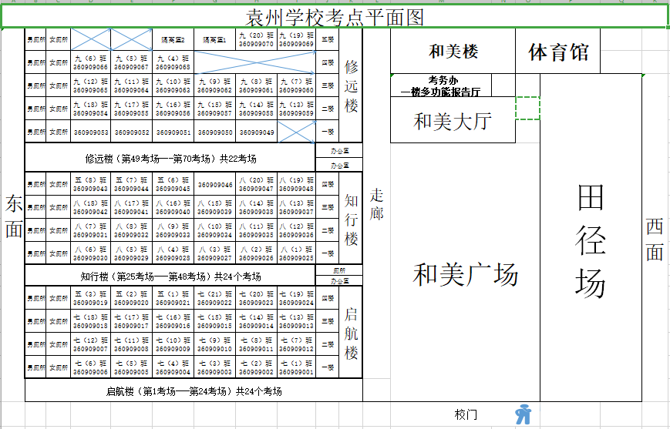

**宜春四中（昌黎中学）考点考场平面示意图**

|  |  |  |  |  |  |  |  |  |  |  |  |
| --- | --- | --- | --- | --- | --- | --- | --- | --- | --- | --- | --- |
|  | | | | | | | | | | | |
|  | **南校门** | | | **笃志楼（初二）（360908041—360908058）** | | | | | | |  |
|  |  |  | **楼梯** | **五楼** |  |  |  |  |  | **楼梯** | **楼梯** |
|  |  |  | **四楼** | **备用考场** | **备用考场** | **360908058** | **360908057** | **360908056** | **卫生间** |
| **操场** |  |  | **三楼** | **360908051** | **360908052** | **360908053** | **360908054** | **360908055** | **办公室** |
| **笃行楼** |  | **二楼** | **360908050** | **360908049** | **360908048** | **360908047** | **360908046** |
|  | **一楼** | **360908041** | **360908042** | **360908043** | **360908044** | **360908045** |
|  |  | **笃思楼（初三）（360908021—360908040）** | | | | | | |  |
|  | **楼梯** | **五楼** |  |  |  |  |  | **楼梯** | **楼梯** |
|  | **四楼** | **360908040** | **360908039** | **360908038** | **360908037** | **360908036** | **卫生间** |
|  | **三楼** | **360908031** | **360908032** | **360908033** | **360908034** | **360908035** | **办公室** |
|  | **二楼** | **360908030** | **360908029** | **360908028** | **360908027** | **360908026** | **二楼考务办** |
|  |  | **一楼** | **360908021** | **360908022** | **360908023** | **360908024** | **360908025** |  |
|  |  |  | **笃学楼（初一）（360908001—360908020）** | | | | | | |  |
| **膳食**  **中心** |  | **楼梯** | **五楼** |  |  |  |  |  | **楼梯** | **楼梯** |
|  | **四楼** | **360908020** | **360908019** | **360908018** | **360908017** | **360908016** | **卫生间** |
|  |  | **三楼** | **360908011** | **360908012** | **360908013** | **360908014** | **360908015** | **办公室** |
|  |  | **二楼** | **360908010** | **360908009** | **360908008** | **360908007** | **360908006** |
|  |  | **一楼** | **360908001** | **360908002** | **360908003** | **360908004** | **360908005** |
|  |  |  |  |  |  |  |  |  |  |  |  |
|  | **北校门** | | |  |  |  |  |  |  |  |  |
|  |  |  |  |  |  |  |  |  |

## 宜阳学校考点考场平面示意图

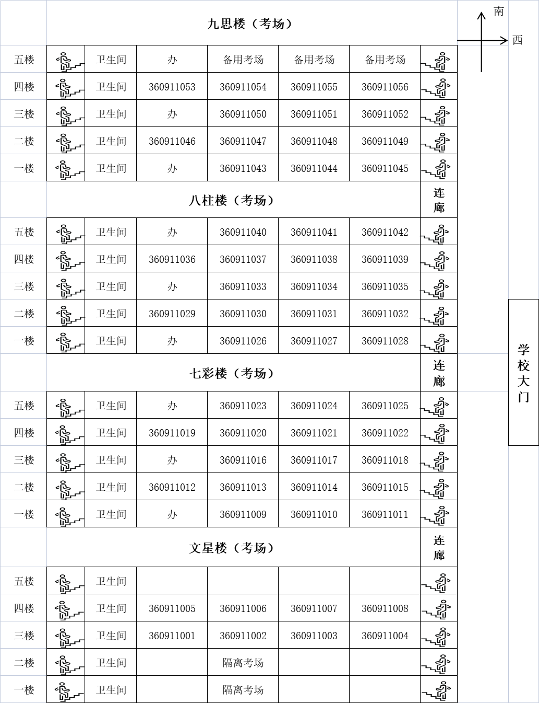

## 官园学校考点考场平面示意图



翰林学校考点考场平面图

|  |  |  |  |  |  |  |  |  |  |  |  |  |  |  |  |  |  |
| --- | --- | --- | --- | --- | --- | --- | --- | --- | --- | --- | --- | --- | --- | --- | --- | --- | --- |
| 2022年下半年教师资格考试（笔试）宜春市翰林学校考点考场平面图 | | | | | | | | | | | | | | | |  |  |
|  | **七号楼考场平面图** | | | | | | | | | |  |  |  |  |  |  |  |
| 运动场 | **办公室** | **九3** | **九4** | **九5** | **备用考场**  **九6** | **备用考场**  **九7** | **360913059考场**  **九8** | **四楼** | **厕所** | **楼梯** |  |  | **南** |  |  |  |  |
| **办公室** | **360913053考场**  **九1** | **360913054考场**  **九2** | **360913055考场**  **八8** | **360913056考场**  **八7** | **360913057考场**  **八6** | **360913058考场**  **八5** | **三楼** | **厕所** | **楼梯** |  |  |  | **西** |  |  |  |
| **办公室** | **360913052考场**  **八1** | **360913051考场**  **八2** | **360913050考场**  **八3** | **360913049考场**  **八4** | **360913048考场**  **七8** | **360913047考场**  **七7** | **二楼** | **厕所** | **楼梯** |  |  |  |  |  |  |
| **办公室** | **360913041考场**  **七1** | **360913042考场**  **七2** | **360913043考场**  **七3** | **360913044考场**  **七4** | **360913045考场**  **七5** | **360913046考场**  **七6** | **一楼** | **厕所** | **楼梯** |  |  |  |  |  |  |
| **通道** | | | | | | | | | |  |  |  |  |  |  |  |
| **六号楼一楼多功能厅考务办** | **通道** | **天井** | | | | | **连廊** |  |  |  |  |  |  |  |  |  |
|  |  |  |  |  |  |  |  |  |
| **五号楼** | | | | | **四号楼** | | | | | | |  |  |
|  |  |
| **篮球场** | | **汉字广场** | | | | |  |  |
| **三号楼考场平面图** | | | | | | |  |  |
|  |  |
|  |  |
| **楼梯** | **360913040考场**  **八10** | **360913039考场**  **四5** | **360913038考场**  **四6** | **360913037考场**  **四7** | **360913036考场**  **四8** | **厕所** | **四楼** |  |
| **360913031考场**  **八11** | **360913032考场**  **四1** | **360913033考场**  **四2** | **360913034考场**  **四3** | **360913035考场**  **四4** |  |
|  | | | | | |  |  |
| **360913030考场**  **三6** | **360913029考场**  **三7** | **360913028考场**  **三8** | **360913027考场**  **三9** | **360913026考场**  **三10** | **厕所** | **三楼** |  |
| **360913021考场**  **三1** | **360913022考场**  **三2** | **360913023考场**  **三3** | **360913024考场**  **三4** | **360913025考场**  **三5** |  |
|  |  |  |  |  | |  |  |
| **360913020考场**  **二6** | **360913019考场**  **二7** | **360913018考场**  **二8** | **360913017考场**  **二9** | **360913016考场**  **二10** | **厕所** | **二楼** |  |
| **360913011考场**  **二1** | **360913012考场**  **二2** | **360913013考场**  **二3** | **360913014考场**  **二4** | **360913015考场**  **二5** |  |
|  | | | | | |  |  |
| **360913010考场**  **五6** | **360913009考场**  **五7** | **360913008考场**  **五8** | **360913007考场**  **五9** | **360913006考场**  **五10** | **厕所** | **一楼** |  |
| **360913001考场**  **五1** | **360913002考场**  **五2** | **360913003考场**  **五3** | **360913004考场**  **五4** | **360913005考场**  **五5** |  |
|  | | | | | |  |  |
|  |  |  |  |  | **厕所** | **架空层** |  |
|  |  |  |  |  |  |
|  |  |  |  |  |  | **二号楼** |  |  |
|  |  |  | **一号楼平面图** |  |  |  |  |
| **楼梯** |  |  |  |  |  | **厕所** | **四楼** |  |
|  |  |  |  |  | **厕所** | **三楼** |  |
|  | | | | | **厕所** | **二楼** |  |
|  | | | | | **厕所** | **一楼** |  |
|  |  |  |  |  | **厕所** | **架空层** |  |
|  |  |  |  |  |  |  |  |  |  |  |  |  |  |  |  |  |
|  |  |  |  |  |  |  |  |  |  |  |  |  |  |  |  |  |
|  | **门卫室** | **东大门** | | **宜春市翰林学校** | | | | **西大门** | | **门卫室** |  | | | |  |  |
|  |  |  |  |  |  |  |  |  |  |  |  |  |  |  |  |  |  |
|  |  |  |  |  |  |  |  |  |  |  |  |  |  |  |  |  |  |